#### UI 2

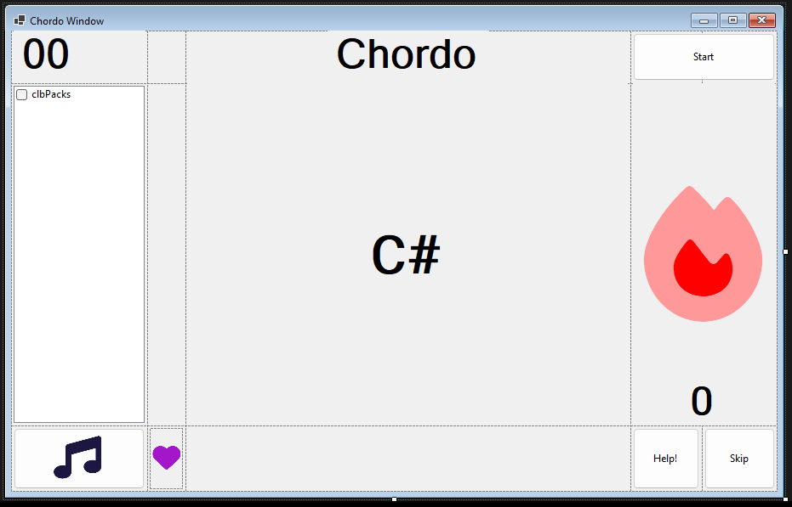

This is a picture of the relevant code and design for this iteration. In this iteration I added a favourite indicator and button (heart bottom left), streak indicator (fire, right), packs selector, (left). I also fixed bugs with stretching images and added a correct/incorrect screen.

It is important to add these images to add some colour and make the app more visually appealing, to increase retention time.

I also added some basic functionality to these buttons and labels, such as for the like button, on click the heart change from full to empty and vice versa, or the streak update function to run on correct answer.

#### Tests 4

|  |  |  |  |
| --- | --- | --- | --- |
| Test Number | Description | Code | Evaluation |
| F4.1a | Scalability of the UI |  | In this small window, all of the buttons fill the space and all of the writing is clear and legible.  PASS |
| F4.1b | Scalability of the UI |  | In this medium window, all of the buttons fit into the space and the writing is legible.  PASS |
| F4.1c | Scalability of the UI |  | In this large UI, The text is a legible size and the buttons feel less spread out.  PASS |
| F4.2a | When a user gets more than three right in a row, a streak count should be present. | This code runs on correct answer    This code runs on incorrect answer | PASS – streak indicator present and functional |
| F4.4a | The user should be able to see whether the chord is favourite or not whilst playing the game | This code runs on heart click and toggles the fill of the heart as an indicator. | FAIL – no favourite indicator present |
| F4.5a, b | Background changes to green when correct | This piece of code makes the screen red and green when the questions are wrong or right. The screens look like this: | PASS - The background changes to green with ticks.  These screens have green and red to be visually striking, but also tick/cross so that colour blind users aren’t disadvantagwd. |
| F4.5c | When timer runs out, red screen |  | PASS – Red screen shown when no answer present |
| U4.6a | There are ticks and crosses on the screen |  | PASS – there a re ticks and crosses so that it is accessible to colour-blind people. |
| F4.7a | There should be a selection of available packs | This bit of code makes a list of the indexes of packs that are checked.    This bit of code passes the list of pack indexes to the revision engine so that it knows what to base the next chords from. | PASS – the user can select a chord pack and it adds it to the possible chords. |
| R4.7b | Check if the user hasn’t selected any chord packs |  | PASS – the program gives a warning dialogue box if there are no chord packs selected. |
| F4.7c | The user selects a chord pack it should be playable | The user selects “Major – beginner”.        These are the expected chords, as these are the chods contained in this chord pack. | PASS – only the chords from the major pack are showed. |
| F4.7d | If a chord pack is unchecked after it is checked it should be removed from the list |  | FAIL – no chord packs selected, chords still show, hasn’t updated available chords. |
| F4.7e | Any chord packs that are listed in the folder should appear in the table |  | PASS – all the chord packs listed are available for selection |
| F4.8a | When the help button is pressed the incorrect sequence should play and a keyboard graphic should appear on screen with the answer |  | PASS – kind of – there is a button but it does nothing yet as it has not been implemented. |
| F4.9a | Toggle sheet music button – onclick, it should display music |  | PASS – kind of – there is a button but it does nothing yet as it has not been implemented |

UI iteration 1 conclusion – Failed test 4.7d, 4.8 and 4.9 are yet to be implemented as they are optional features.